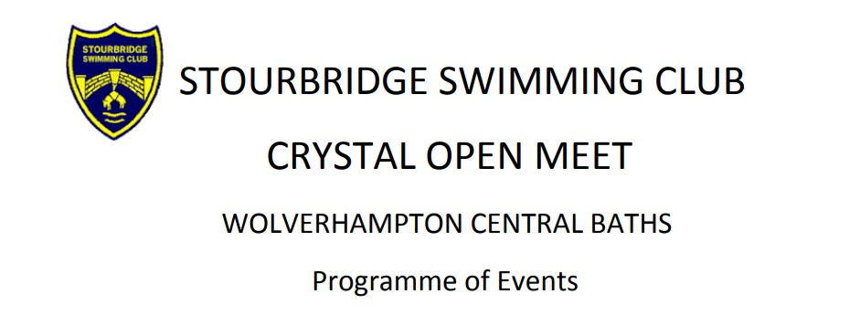
Affiliated to West Midlands Region and swum under SE Regulations and
Technical Rules
Saturday 24th February 2024
Session times to be confirmed
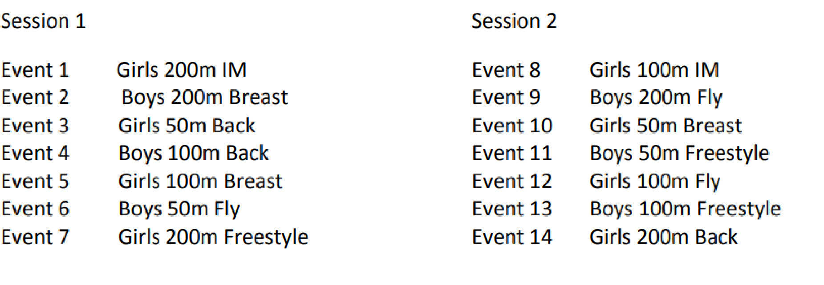
Sunday 25th February 2024
Session times to be confirmed
