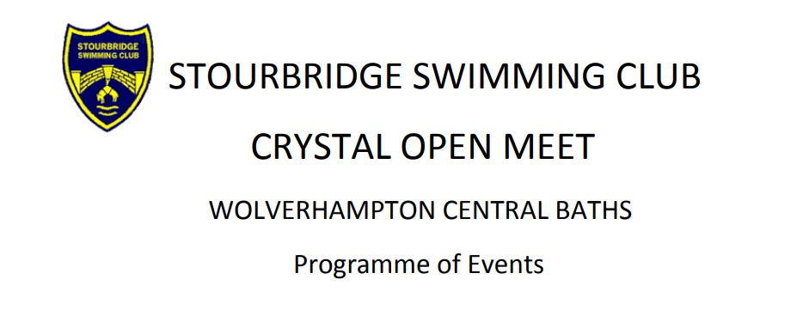
Affiliated to West Midlands Region and swum under SE Regulations and
Technical Rules
Saturday 24th February 2024
Session times to be confirmed
Session 1 Session 2

Event 1 Female 200m IM Event 8 Female 100m IM
Event 2 Open/Male 200m Breaststroke Event 9 Open/Male 200m Butterfly
Event 3 Female 50m Backstroke Event 10 Female 50m Breaststroke
Event 4 Open/Male 100m Backstroke Event 11 Open/Male 50m Freestyle
Event 5 Female 100m Breaststroke Event 12 Female 100m Butterfly
Event 6 Open/Male 50m Butterfly Event 13 Open/Male 100m Freestyle
Event 7 Female 200m Freestyle Event 14 Female 200m Backstroke

Sunday 25th February 2024
Session times to be confirmed
Session 3 Session 4

Event 15 Open/Male 200m IM Event 22 Open/Male 100m IM
Event 16 Female 200m Breaststroke Event 23 Female 200m Butterfly
Event 17 Open/Male 50m Backstroke Event 24 Open/Male 50m Breaststroke
Event 18 Female 100m Backstroke Event 25 Female 50m Freestyle
Event 19 Open/Male 100m Breaststroke Event 26 Open/Male 100m Butterfly
Event 20 Female 50m Butterfly Event 27 Female 100m Freestyle
Event 21 Open/Male 200m Freestyle Event 28 Open/Male 200m Backstroke

